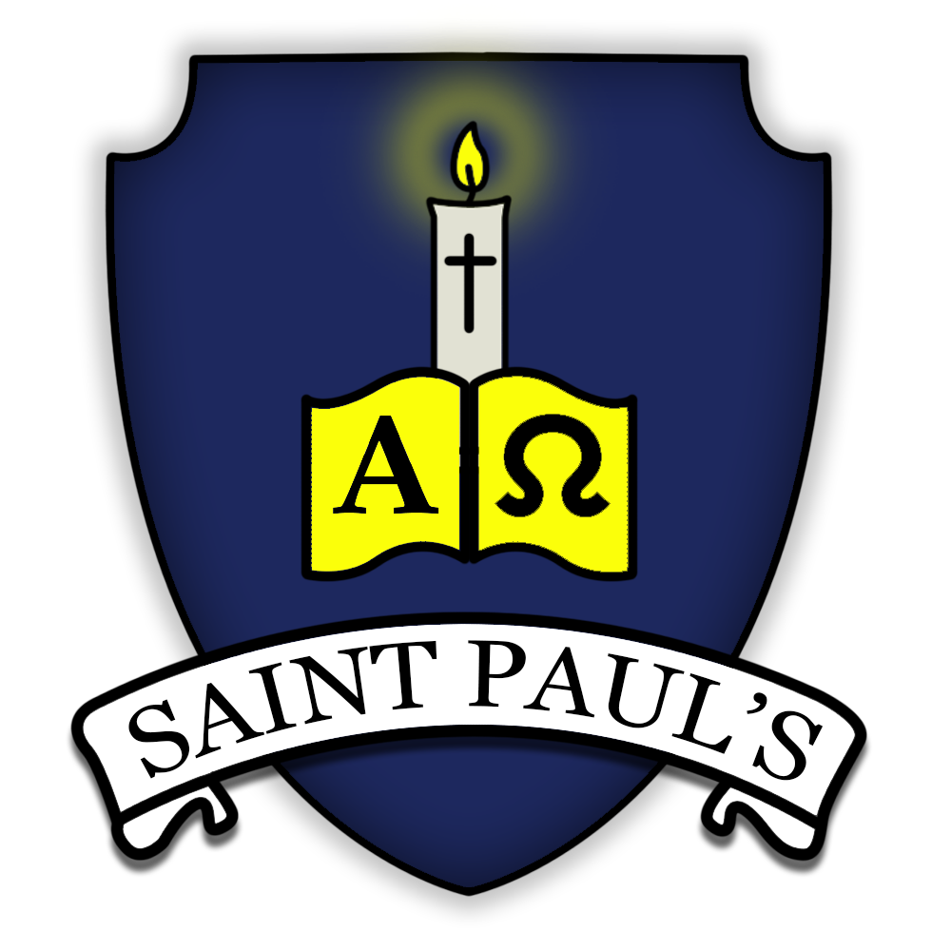
Spring term in Year 4 at St Paul’s

Welcome back to Year 4! We hope you had a wonderful Christmas and are looking forward to another exciting term of learning.

Who’s who
Miss Spiers (Class Teacher) | Miss Castle (one to one support)

Contact details
Miss Spiers
e.spiers@plymouthcast.com

You can also contact us through Class Dojo. If your child is ill please email the office or call the school, do not message your class teacher through Class Dojo. We will be regularly updating our class page on Class Dojo with photos of our learning.

Practical arrangements
Break - 10.15 - 10.30 on the KS2 playground.
Lunch - 12.10 on the KS2 playground
PE days - Tuesday and Friday (please come to school in your PE uniform)

Key dates
Parents evening - Week beginning 21st March
Class Mass - 25th January, 1st March and 29th March - 10 am in church
School trips - Eden Project (Date TBC)
World book day/Books at Bedtime - Thursday 3rd March

Attendance
We are currently monitoring the attendance of all children as it has a huge impact on their learning. While we

Healthy eating
We are committed to being a healthy school. Children in KS2 (Years 3-6) need to bring a snack for morning break. Please support your child to develop good eating habits. Crisps or chocolate are not acceptable for a morning snack. All children require water bottles for use in class. These must have a sports cap so that school books are not at risk of being damaged. School water bottles are available to purchase from the school office. Only water is allowed to be consumed in class time.

School uniform policy
- White polo shirts: Reception class only
- White shirts and ties in KS1 and KS2
- Grey trousers/shorts
- Navy blue skirt/pinafore/trousers
- Navy blue sweatshirts/jumpers/ cardigans
- Blue summer dresses (summer term only)
- White or navy blue tights or socks
- Flat heeled black shoes (no boots or flip flops)
- PE: House t-shirt and navy blue shorts
- Black plimsolls (or PE trainers in KS2)

Labelling - It is very important that all items of clothing and other belongings are clearly marked with the owner’s name at all times.

Jewellery - For safety reasons, children should not wear jewellery to school. Children may only have one ear piercing, they can only wear discrete studs, although these must be removed for PE and swimming.

Sports Kit - On PE days, pupils should come to

school dressed for PE.
Pupils may wear navy tracksuit bottoms in colder weather. Pupils are not allowed to wear any other sportswear - PE days are not non-uniform days and it is important that standards remain high.
Pupils in KS2 may wear black plimsolls or PE trainers. Only trainers suitable for PE will be accepted.

Reading records
Your child will bring home a reading record which is to come into school each day with their reading book. Please record each time you hear your child read. You could comment on their attitude and interest towards reading, their comprehension and understanding of what they read or their word and phonic knowledge. There are stickers in the middle of the journal to help encourage your child to engage with the reading record.

Home learning
All home learning will be set through Google Classroom. Home learning will be set on a Friday and due the following Friday.

Our Learning this Year
Subject Area | Autumn 1 | Autumn 2 | Spring 1 | Spring 2 | Summer 1 | Summer 2
Trip/experience | The Box - Tudor workshop | Electricity workshop in school | Trip to the Eden Project- Geography (Climates/Earthquakes) | Trip to the Hoe/Barbican/Lighthouse - History of Plymouth | Invite parents in to taste and try food (DT) | Trip to Dartmoor zoo - Animals including humans (Science)
English units | The Whale (F) (4 wks)  The Plague (Playscript)(3 wks) | Float (F) (4 wks) | Charlie and the Chocolate Factory (F)  (4 wks) | Sicily Holiday Brochure (NF)  (4 wks) | The Journal of Iliona - A Young Slave (Y3 unit ) (NF) | Still I rise (Poetry) (3 wks)  Earthquakes (Y3 unit)  (NF)
Class novel | The boy at the back of the class |  | Max and the Millions |  | The Firework Maker’s Daughter
Maths | Place Value  4-digit numbers (1)  4-digit numbers (2)  Addition and subtraction | Measure- Perimeter  Multiplication and Division (1) | Multiplication and Division 1-2  Measure- Area  Fractions (1) | Fractions 1-2  Decimals (1) | Decimals (2)  Money  Time | Statistics  Geometry-angles and 2D shapes  Geometry - position and direction.
RE | Domestic Church  Baptism/Confirmation | Baptism/Confirmation  Islam  Sikhism  Advent | Community  Eucharist | Eucharist  Hinduism  Lent | Pentecost  Judaism | Reconciliation  Universal Church
PSHE/SMSC (Live life to the full modules throughout the year) | Transition | Economic well-being | Road safety  My community | Aspirations  Drugs education | Water safety  Rail safety | Responsibilities  Transition
Science | Living things and their habitats | Sound  Evaluation- WS skills | States of matter  Data- WS skills |  | Animals including humans | Electricity  Planning- WS skills
Art/DT | Formal elements of art  Art and design skills |  | Every picture tells a story |  | Sculpture
 | Torches |  | Fastenings |  | Adapting a recipe
Computing | The internet | Audio editing | Photo editing | Data logging | Repetition in shapes | Repetition in games
Online Safety  Twice a term | Self-image and  identity and online  reputation | Online relationships | Online bullying | Managing online  information | Health, wellbeing  and lifestyle | Privacy and security  Copyright and  ownership
Geography | Water: friend or foe? |  | The angry earth: why and where do earthquakes occur? |  | Intriguing Italy
History | How did England change under the Tudors? |  | How has Plymouth changed over the last 100 years? |  | What impact did the Romans have on Britain?
Music | Mamma Mia  Glockenspiel Stage 2 |  | Stop!  Lean on Me |  | Blackbird  Refect, Rewind, Replay
PE | Invasion Games - Ball on the ground | Gymnastics | Dance | Gymnastics | Invasion Games - Net games | Athletics
MFL | Spanish and Classics

