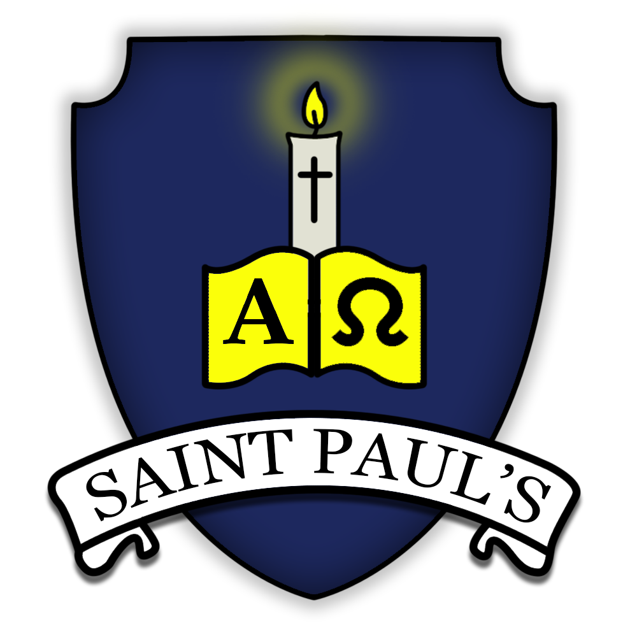
All About Year 4 at St Paul’s

Welcome to Year 4! We are really excited about all the learning opportunities that we have planned for the class this year. This newsletter will tell you everything that you need to know about your time in Year 4.

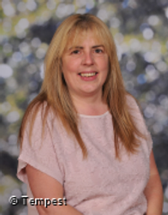
Who’s who
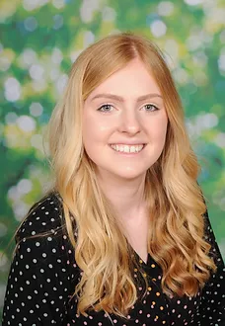  Miss Spiers - Class Teacher | Mrs Reid (Teaching assistant Monday and Friday )

Contact details
Miss Spiers
e.spiers@plymouthcast.com

You can also contact us through Class Dojo. If your child is ill please email the office or call the school, do not message your class teacher through Class Dojo. We will be regularly updating our class page on Class Dojo with photos of our learning.

Practical arrangements
Break - 10.30 - 10.45 on the KS2 playground.
Lunch - 12.10 on the KS2 playground
PE days - Wednesday and Friday (please come to school in your PE uniform)
PPA time - On a Wednesday afternoon, Miss Spiers has release time out of class. The class will be taught languages and PE during this time.

Healthy eating
We are committed to being a healthy school. All Foundation stage and KS1 children are provided with fresh fruit on a daily basis and do not require any additional snacks. Children in KS2 (Years 3-6) need to bring a snack for morning break. Please support your child to develop good eating habits. Crisps or chocolate are not acceptable for a morning snack. All children require water bottles for use in class. These must have a sports cap so that school books are not at risk of being damaged. School water bottles are available to purchase from the school office. Only water is allowed to be consumed in class time.

School uniform policy
- White polo shirts: Reception class only
- White shirts and ties in KS1 and KS2
- Grey trousers/shorts
- Navy blue skirt/pinafore/trousers
- Navy blue sweatshirts/jumpers/ cardigans
- Blue summer dresses (summer term only)
- White or navy blue tights or socks
- Flat heeled black shoes (no boots or flip flops)
- PE: House t-shirt and navy blue shorts
- Black plimsolls (or PE trainers in KS2)
Labelling - It is very important that all items of clothing and other belongings are clearly marked with the owner’s name at all times.

Jewellery - For safety reasons, children should not wear jewellery to school. Children may only have one ear piercing, they can only wear discrete studs, although these must be removed for PE and swimming.

Sports Kit - On PE days, pupils should come to school dressed for PE.
Pupils may wear navy tracksuit bottoms in colder weather. Pupils are not allowed to wear any other sportswear - PE days are not non-uniform days and it is important that standards remain high.
Pupils in KS2 may wear black plimsolls or PE trainers. Only trainers suitable for PE will be accepted.

Reading records
Your child will bring home a reading record which is to come into school each day with their reading book. Please record each time you hear your child read. You could comment on their attitude and interest towards reading, their comprehension and understanding of what they read or their word and phonic knowledge. There are stickers in the middle of the journal to help encourage your child to engage with the reading record.

Spelling
We will not be sending spellings home weekly to be tested any more as not only does this cause unnecessary stress for your child and yourselves at home, it has been proven that children do not learn their spellings through this method. Instead we would really like you to focus on hearing your child read and reading to your child at home.

Home learning
We are currently reviewing our home learning policy and will share details with you as soon as they are finalised. In the meantime, please encourage your child to read regularly and engage with TTRS and/or Numbots.

SEND
Mrs Barnes has the role of SENDCO in our school. She works closely with our Parent Support Adviser (PSA) and Learning Mentor, Mrs Foweraker, to support your children in and out of the classroom. Any concerns you have should initially go through your child’s class teacher. This will enable us to work together to decide on the best strategies to support your child for example through the use of fidget toys which can be agreed together. For children where additional needs are identified, an Individual Education Plan (IEP) will be written with 3/4 clear targets. These will be shared with you by the end of September, reviewed after approximately 6 weeks and then new targets set at the end of the Autumn, Spring and Summer terms.

Information about core subjects
Maths
As a school, we follow the Power Maths programme for maths from Reception to Year 6. Power Maths is a UK curriculum mastery programme designed to spark curiosity and excitement and nurture confidence in maths.
An enriched approach that cleverly combines interactive teaching tools, rich and quality textbooks and practice books, built around a child‑centred lesson design that models and embeds a growth mindset approach to maths and focuses on helping all children to build a deep understanding of maths concepts.
In KS1 and 2, practice books provide just the right amount of intelligent practice for children to complete independently in the final section of the lesson. There is one practice book per term for each year group from Year 1-6.

Writing
As a school, we have adopted “The Write Stuff” by Jane Considine to bring clarity to the mechanics of writing. “The Write Stuff” follows a method called “Sentence Stacking” which refers to the fact that sentences are stacked together and organised to engage children with short, intensive moments of learning that they can then immediately apply to their own writing. An individual lesson is based on a sentence model, broken in to three chunks:
- Initiate section – a stimulus to capture the children’s imagination and set up a sentence. This is where key vocabulary is gathered ready to use in writing.
- Model section – the teacher models a sentence that outlines clear writing features and techniques.
- Enable section – the children write their sentence, following the model.
The children use the writing rainbow to give focus and purpose for each sentence they write.

Reading
We teach reading through a whole class approach in school in the same way that we teach maths and writing. In those lessons we look at different extracts from books and answer questions that link to our reading skills - vocabulary, inference, prediction, explanation, retrieval and summary/sequencing.

Our KS2 children will bring home reading books which are linked to their reading level on Accelerated Reader. They will be retested once a term to see whether their reading level has changed. Each book has a quiz for the children to complete once they have finished reading. These quizzes can be accessed at home or in school. The website to access these quizzes is: https://ukhosted95.renlearn.co.uk/2236538/ Children are rewarded with Dojo points for getting 100%, 90% or 80% in their quizzes so be sure to write this in their reading record if they achieve that at home. Completing regular quizzes also helps them to work through the reading levels which they will receive certificates for.
For children still accessing our RWINc phonics programme their reading books will be matched to their phonic knowledge. This means they should be able to read relatively independently. The children will bring home two reading books, the first is from our home reading scheme and the second is a copy of the text they are reading in their phonic sessions. Your child will be expected to reread these books. Rereading books is good practice as it moves children from reading for decoding, through reading with expression and finally onto reading for meaning. Please listen to your child read and, more importantly, talk about what is being read as often as you can.

RE
As a school, we use the published scheme ‘Come and See’ as a resource to teach the curriculum. ‘Come and See’ is a Catholic Primary Religious Programme for Reception, Key Stage 1 and Key Stage 2 written by a group of experienced diocesan advisors. It is based on the theological foundations of the Second Vatican Council, the Catholic Catechism and the revised RE Curriculum Directory.
Each unit follows the pattern of Explore, Reveal and Respond which allows the children to use their own life experiences to link with religious teaching. Scripture, prayers and tradition are at the heart of revealing the Christ faith to the children with time at the end of each unit for the children to reflect and respond to what they have learnt.

Our Learning this Year
Subject Area |  | Autumn 1 |  | Autumn 2 | Spring 1 | Spring 2 | Summer 1 | Summer 2
Trip/experience |  | The Dome- Sound experience |  |  | Trip to the Hoe/Barbican/Lighthouse - History of Plymouth  or The Box Museum |  | Dartmoor Zoo
English units |  | The Whale (F)  Still I Rise (Poetry) |  | Float (F) | Charlie and the Chocolate Factory (F) | The Lost Thing (F) | Theseus and the Minotaur (F) | Sicily Holiday Brochure (NF)
Class novel |  | Popcorn Eating Squirrels Go Nuts on Everest |  |  | The Boy at the Back of the Class |  | The Animal Lighthouse
Maths |  | Place Value  4-digit numbers (1)  4-digit numbers (2)  Addition and subtraction |  | Measure- Perimeter  Multiplication and Division (1) | Multiplication and Division 1-2  Measure- Area  Fractions (1) | Fractions 1-2  Decimals (1) | Decimals (2)  Money  Time | Statistics  Geometry-angles and 2D shapes  Geometry - position and direction.
RE |  | Domestic Church  Baptism/Confirmation |  | Baptism/Confirmation  Islam  Sikhism  Advent | Community  Eucharist | Eucharist  Hinduism  Lent | Pentecost  Judaism | Reconciliation  Universal Church
PSHE/SMSC (Live life to the full modules throughout the year) |  | Transition |  | Economic well-being | Road safety  My community | Aspirations  Drugs education | Water safety  Rail safety | Responsibilities  Transition
Science |  | Sound  Evaluation- WS skills |  | Living things and their habitats | States of matter  Data- WS skills |  | Animals including humans | Electricity  Planning- WS skills
Art/DT |  | Formal elements of art  Art and design skills |  |  | Every picture tells a story |  | Sculpture
 |  | Torches |  |  | Adapting a recipe |  | Fastenings
Computing |  | The internet |  | Audio editing | Photo editing | Data logging | Repetition in shapes | Repetition in games
Online safety  Twice a term |  | Self-image and  identity and online  reputation |  | Online relationships | Online bullying | Managing online  information | Health, wellbeing  and lifestyle | Privacy and security  Copyright and  ownership
Geography |  | Rivers - Why are Rivers important to us? |  |  | The UK - How has the UK changed over time? |  | Our Local Area - Our Local National Park Dartmoor
History |  | How did England change under the Tudors? |  |  | How has Plymouth changed over the last 100 years? |  | What impact did the Romans have on Britain?
Music |  | Mamma Mia  Glockenspiel Stage 2 |  |  | Stop!  Lean on Me |  | Blackbird  Refect, Rewind, Replay
PE |  | Invasion Games - Ball on the ground |  | Dance | Swimming  Gymnastics (PPA) | Gymnastics | Invasion Games - Net games | Athletics
 |  | Spanish and Classics

