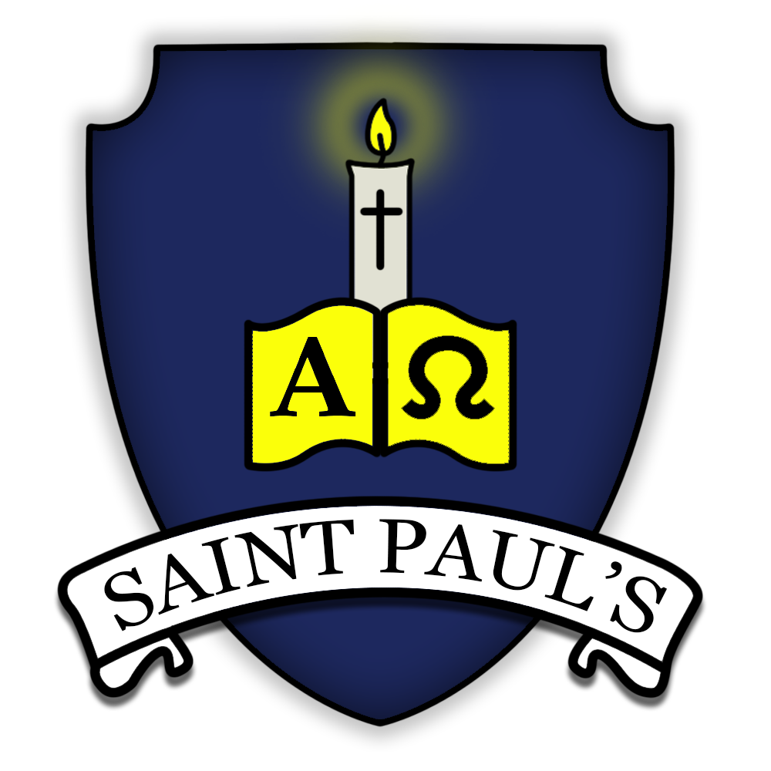
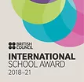


St Paul’s Catholic Primary School
TERM DATES 2021/2022
AUTUMN TERM 2021

Non-Pupil Day (school closed to pupils) Monday 6th September 2021
Autumn Term commences on Tuesday 7th September 2021
Half Term Week (inclusive) Monday 25th October – Friday 29th October 2021
Non-Pupil Day (school closed to pupils) Monday 1st November 2021
Term commences on Tuesday 2nd November 2021
Term Finishes (last day of term) Friday 17th December 2021

SPRING TERM 2022

Bank Holiday Monday 3rd January 2022
Spring Term commences on Tuesday 4th January 2022
Non-Pupil Dat (school closed to pupils) Friday 18th February 2022
Half Term Week (inclusive) Monday 21st February – Friday 25th February 2022
Non-Pupil Day (school closed to pupils) Monday 28th February 2022
Term commences on Tuesday 1st March 2022
Term finishes (last day of term) Friday 8th April 2022

SUMMER TERM 2022

Summer Term commences on Monday 25th April 2022
May Day Bank Holiday (school closed) Monday 2nd May 2022
Term finishes (last day of term) Friday 27th May 2022
Half Term Week (inclusive) Monday 30th May – Friday 3rd June 2022
Non-Pupil Day (school closed to pupils) Monday 6th June 2022
Term commences on Tuesday 7th June 2022
Term finishes (last day of term) Tuesday 26th July 2022

