ST PAUL’S RC PRIMARY SCHOOL

LETTINGS POLICY

Agreed: Autumn Term 2014
Reviewed: January 2018
Review date: January 2020

LETTING OF SCHOOL PREMISES POLICY

1. INTRODUCTION
Definition of Letting
A letting may be defined as “any use of the school premises (buildings and grounds) by either a community group (such as a local music group or football team), or a commercial organisation (such as the local branch of ‘Weight Watchers’)”. A letting must not interfere with the primary activity of the school, which is to provide a high standard of education for all its pupils.
Use of the premises for activities such as staff meetings, parents’ meetings, Governing Body meetings and extra-curricular activities of pupils supervised by school staff, fall within the corporate life of the school. Costs arising from these uses are therefore a legitimate charge against the school’s delegated budget.
Charges for a Letting
The Governing Body is responsible for setting charges for the letting of the school premises. A charge will be levied which covers the following:
- Cost of services (heating and lighting);
- Cost of staffing (additional security, caretaking and cleaning) - including “on-costs”;
- Cost of administration;
- Cost of “wear and tear”;
- Cost of use of school equipment (if applicable);
- Profit element (if appropriate).
Where there are multiple lettings taking place at the same time, the costs for services and staffing will normally be shared between the organisations involved.
When the school is being used for election purposes a lettings request form will still need to be completed, but no charge will be made as the Local Authority will reimburse the school with a token payment to cover the utility charges.
When a Community organisation i.e. PACLS or Youth Service require a period of hire to deliver their services, charges should only be made to cover the costs: electricity, gas, water and administration. A substantial profit should not be made when the community uses the school’s facilities.
The specific charge levied will be reviewed annually, during the spring term, by the Premises Committee, for implementation from the beginning of the next financial year. Current charges will be provided in advance of any letting being agreed.

2. VAT
In general, the letting of rooms for non-sporting activities is exempt of VAT, whereas sports lettings are subject to VAT (although there are exemptions under certain circumstances). Where the letting is for a continuous period please refer to Plymouth CAST VAT Manual.9. VAT is a complex area, and you are advised to refer to the VAT Manual or contact the Plymouth CAST Finance Manager for advice.

Sporting facilities charges – VAT
Sport facility letting charges are normally subject to VAT, but where certain criteria are satisfied, the hire charges can be treated as exempt.
VAT Regulations state that for a series of ten or more lettings to be exempt from VAT, the following conditions should be satisfied:
- Each period is in respect of the same activity carried on at the same place;
- The interval between each period is not less than one day and not more than fourteen days;
- The charge is payable by reference to the whole series and is evidenced by written agreement;
- The facilities are letting to a school, club, association or an organisation representing affiliated clubs or constituent association.
When letting the general purpose school hall for a sporting activity it will be exempt from VAT. VAT is only added when the facility being let is specifically for that sporting purpose i.e. Swimming pool – being let for a swimming pool sporting activity.
On the letting of sports facilities for sports, the VAT exemption does not apply to commercial organisations.

3. MANAGEMENT AND ADMINISTRATION OF LETTINGS
The Head Teacher is responsible for the management of lettings, in accordance with the Governing Body’s policy. Where appropriate, the Head Teacher may delegate all or part of this responsibility to other members of staff, whilst still retaining overall responsibility for the lettings process.
If the Head Teacher has any concern about whether a particular request for a letting is appropriate or not, he will consult with the Chair of the Premises Committee (or alternative, as appropriate), who is empowered to determine the issue on behalf of the Governing Body.
Safeguarding and Child Protection
The Governing Body is responsible for ensuring that the school has effective policies and procedures for safeguarding children and young people (S.175 Education Act 2002). Where school premises are let to other organisations, and children/young people participate in the business/service of the hirer (i.e. they are on site during the specified times of hiring), the Governing Body will seek written assurance that the hirer has appropriate policies and procedures in place with regard to safeguarding children and child protection. Most importantly in these circumstances, the Governing Body will require written assurance from the hirer that all those engaged by the hirer (i.e. staff and/or helpers) to supervise children or regularly work with them in any other capacity, have been vetted, where necessary, through the DBS process and are deemed suitable for the role. Where these written assurances have been given and the Governing Body is made aware that the said arrangements are not in place, the Governing Body reserves the right to terminate the contract with immediate effect and without any financial liability falling to the school. Similarly, the Governing Body reserves the right to see the hirer's policies/procedures regarding safeguarding and child protection where they deem it necessary.
The Administrative Process
Organisations seeking to hire the school premises should approach the Head Teacher (or other designated member of staff), who will identify their requirements and clarify the facilities available. A School Letting Request Agreement (a copy of which is found in Section 5.2) should be completed at this stage. The Governing Body has the right to refuse an application, and no letting should be regarded as “booked” until approval has been given in writing. No public announcement of any activity or function taking place should be made by the organisation concerned until the booking has been formally confirmed.
Once a letting has been approved, a letter of confirmation will be sent to the hirer, setting out full details of the letting and enclosing a copy of the terms and conditions and the hire agreement.
The letting should not take place until the signed agreement has been returned to the school. The person applying to hire the premises will be invoiced for the cost of the letting, in accordance with the Governing Body’s current scale of charges. Schools may wish to seek payment in advance in order to reduce any possible bad debts.
The hirer should be a named individual and the agreement should be in their name, giving their permanent private address. This avoids any slight risk that the letting might be held to be a business tenancy, which would give the hirer security of tenure.
All lettings fees which are received by the school will be paid into the main school budget in order to offset the costs of services, staffing etc (which are funded from the school’s delegated budget). Income and expenditure associated with lettings will be regularly monitored to ensure that at least a “break even” situation is being achieved.

4 TERMS AND CONDITIONS FOR THE HIRE OF THE SCHOOL PREMISES
- All terms and conditions set out below must be adhered to. The “Hirer” shall be the person making the application for a letting, and this person will be personally responsible for payment of all fees or other sums due in respect of the letting.
- Status of the Hirer
- Lettings will not be made to persons under the age of 18, or to any organisation or group with an unlawful or extremist background. The hire agreement is personal to the hirer only, and nothing in it is intended to have the effect of giving exclusive possession of any part of the school to them or of creating any tenancy between the school and the hirer.
- Persons involved with the hire may have to undergo a criminal record check via the Disclosure and Barring Service (DBS). Further advice and guidance around the requirement for DBS checks when hiring premises can be obtained from the school office Where DBS checks are necessary, these checks must be made in advance of the hire to ensure that clearance is confirmed prior to the hire taking place.
- Any adults working with the school’s pupils (for example, at an after school sports club) must be appropriately qualified. Sports coaches must follow the LA’s guidelines for working in schools.
- Sub-letting
- The Hirer shall not sub-let the premises to another person.
- Priority of Use
- The Head Teacher will resolve conflicting requests for the use of the premises, with priority at all times being given to school functions.
- Right of Access
- The Governing Body reserves the right of access to the premises during any letting. The Head Teacher or members of the Governing Body from the Premises Committee may monitor activities from time to time.
- Attendance
- The Hirer shall ensure that the number of persons using the premises does not exceed that for which the application was made and approval given.
- Behaviour
- The Hirer shall be responsible for ensuring the preservation of good order for the full duration of the letting and until the premises are vacated.
- Public Safety
- The Hirer shall be responsible for the prevention of overcrowding (such as would endanger public safety), and for keeping clear all gangways, passages and exits. The Hirer shall be responsible for providing adequate supervision to maintain order and good conduct, and - where applicable - the Hirer must adhere to the correct adult/pupil ratios at all times.
- Own Risk
- It is the Hirer's responsibility to ensure that all those attending are made aware of the fact that they do so in all respects at their own risk.
- Damage, Loss or Injury
- The Hirer warrants to the Governing Body that it has appropriate public liability insurance to cover all its legal liabilities for accidents resulting in injuries to persons (including all participants in the activity for which the premises are being hired), and/or loss of or damage to property, including the hired premises, arising out of the letting. The minimum limit for this insurance cover is £5 million. The Hirer must produce the appropriate certificate of insurance cover before the letting can be confirmed.
- Insurance for One-off Lettings
- Individuals should be asked whether they have any contents insurance and if so, to check whether it will cover their personal liability for the purposes of the let. If covered, they must provide appropriate evidence (confirmation from the insurers that the event is covered and the policy is in force on the relevant date). The minimum acceptable limit of liability should be £5m.
- If the Hirer does not have their own insurance, then cover can be arranged by Plymouth CAST for 10% of the hire charge. This premium will need to be passed to Plymouth CAST for it to be paid to the insurers. Please note that the Plymouth CAST’s insurance will not cover the use of bouncy castles unless they are hired with an operator who has the appropriate liability insurance.
- This cover can also be arranged for Group Hirers (club etc) who do not have any or sufficient (£5m) public liability insurance of their own.
- If the Governors have agreed for a Letting to be free of charge and insurance cover is required, the premium should be calculated based upon what the hire charge would have been.
- Neither the school, nor Plymouth CAST, will be responsible for any injury to persons or damage to property arising out of the letting of the premises.
- Furniture and Fittings
- Furniture and fittings shall not be removed or interfered with in any way. No fittings or decorating of any kind necessitating drilling, or the fixing of nails or screws into fixtures which are part of the school fabric, are permitted. In the event of any damage to premises or property arising from the letting, the Hirer shall pay the cost of any reparation required.
- School Equipment
- This can only be used if requested on the initial application form, and if its use is approved by the Head Teacher. Responsible adults must supervise the use of any equipment which is issued and ensure its safe return. The Hirer is liable for any damage, loss or theft of school equipment they are using, and for the equipment's safe and appropriate use.
- Electrical Equipment
- Any electrical equipment brought by the Hirer onto the school site MUST comply with Plymouth CAST’s code of practice for portable electrical appliance equipment. Equipment must either have a certificate of safety from a qualified electrical engineer or be inspected by the school. The intention to use any electrical equipment must be notified on the application.
- Car Parking Facilities
- Subject to availability, these may be used by the Hirer and other adults involved in the letting.
- Toilet Facilities
- Access to the school’s toilet facilities is included as part of the hire arrangements.
- First Aid Facilities
- There is no legal requirement for the school to provide first aid facilities for the Hirer. It is the Hirer's responsibility to make their own arrangements, such as the provision of first aid training for supervising personnel, and the provision of a first aid kit, particularly in the case of sports lettings. Use of the schools resources is not available.
- Food and Drink
- No food or drink may be prepared or consumed on the property without the direct permission of the Governing Body, in line with current food hygiene regulations. All litter must be placed in the bins provided.
- Intoxicating Liquor
- No intoxicants shall be brought on to or consumed on the premises.
- Smoking
- The whole of the school premises is a non-smoking area, and smoking is not permitted.
- Heels and Shoes
- No stiletto or any type of thin heel is to be worn. If activities involve outdoor use, participants should ensure footwear is cleaned before re-entering the premises.
- Copyright or Performing Rights
- The Hirer shall not, during the occupancy of the premises, infringe any subsisting copyright or performing right, and shall indemnify the school against all sums of money which the school may have to pay by reason of an infringement of copyright or performing right occurring during the period of hire covered by this agreement.
- Charges
- Hire charges are reviewed annually and the current charge is set out in the Hire Agreement.
- Variation of Scales of Charges and Cancellations
- The Hirer acknowledges that the charges given may be increased from time to time (they will be reviewed by the Governing Body on an annual basis) and that the letting may be cancelled, provided that in each circumstance at least 28 day’s notice either way is given. It is the Hirer's responsibility to notify parents in writing (where appropriate) of any changes in dates or venues at least a week in advance.
- Security
- The Governors will hire and pay for a person to be responsible for the security of the premises before, during and after the hire, and for the cleaning of the premises after its use. This cost will be included in the charge for the letting. Whilst hirer’s are using the facilities they can be delegated responsibility for the security of the premises, they will still have to cover the costs incurred for a school representative to open and close the school. If no suitable person can be employed, then the letting will not be allowed or will be cancelled. Only named key holders may operate the security system. Keys should not be passed to any other person without direct permission of the Governing Body of the school.
- Conclusion of the Letting
- The Hirer shall, at the end of the hire period, leave the accommodation in a reasonably tidy condition, all equipment being returned to the correct place of storage. If this condition is not adhered to, an additional cost may be charged.
- Vacation of Premises
- The Hirer shall ensure that the premises are vacated promptly at the end of the letting. The Hirer is responsible for supervising any children taking part in an activity until they are collected by a responsible adult. In the event of an emergency, occupants must leave the school by the nearest exit and assemble on the school playground. The Hirer must have immediate access to participants’ emergency contact details, and may use the telephone in the school office in the event of an emergency. Hirers are responsible for familiarising themselves with emergency exits and must ensure that participants are aware of evacuation procedures.
- Promotional Literature/Newsletters
- A draft copy of any information to be distributed to participants or through the school must be sanctioned by the Head Teacher a week prior to distribution by the Hirer.

Policy adopted by Plymouth CAST Board of Directors at the meeting dated
Signed
(Chair)
Review cycle: Bi-annual Next review date

- APPENDIX A

- LETTINGS CALCULATOR
- The Plymouth CAST Finance Manager has a letting charges calculator that will enable the school to calculate the breakeven costs involved in the letting of any room within the school. The calculator is in the format of an excel spreadsheet which requires completion with certain information to provide a unit cost. Please look at the following advice below:
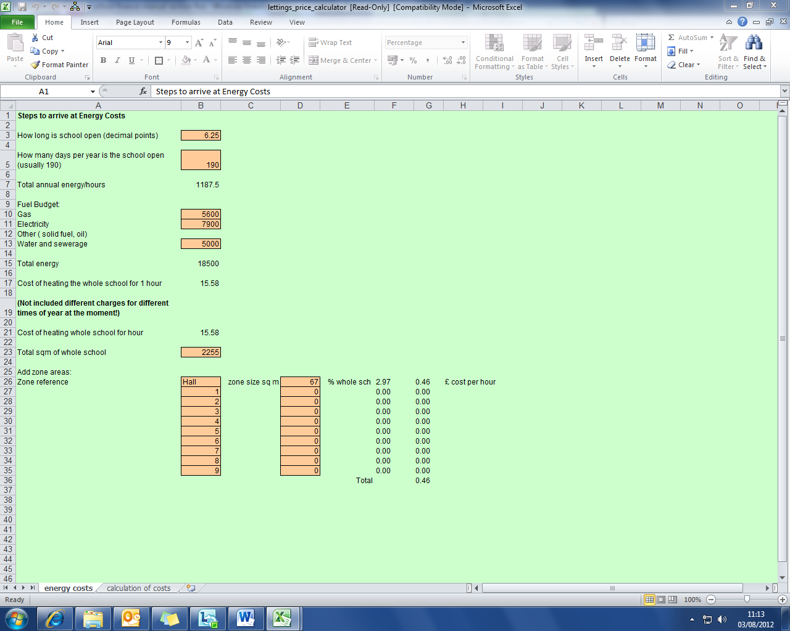

Enter Relevant School Data into data boxes, all orange boxes are available to be updated and will need to be completed using the unique data for your school.

Information required to be able to complete the lettings calculator include the following:
- Times school is open
- No of days school is open
- Energy budgets for the year
- Total floor area of school
- Floor area values for relevant rooms that are to be hired

The second tab on the calculator then enables you to add the staffing costs involved in the lettings process. Once this has been completed the calculator shows hourly rates that can be charged to hirers, including the ability to add a 15% margin for private users to cover administrative costs.

Lettings charges should be evaluated and calculated on an annual basis.

